Indonesia: Recent Economic Developments and Outlook

# GDP growth in 2019 picked up

GDP growth picked up by 5.0% year-on-year (yoy) in 2019. On the demand side, private consumption (57.9% of GDP) contributed the most to growth, with 2.9 percentage points (pp). On the supply side, services (44.2% of GDP) contributed the most to growth, with 2.8pp.

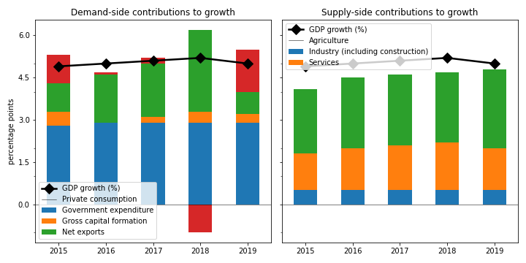

## Private consumption grew the fastest on the demand side

Private consumption grew by the largest margin (5.2%). Government expenditure jumped by 3.2%. Gross capital formation expanded by 2.4%. On the other hand, net exports decreased by 50.4%.

## On the supply side, services increased the fastest

Services increased the most rapidly (6.4%). Industry (including construction) grew by 3.8%. Agriculture grew by 3.6%.

## Unemployment declined; inflation improved

Unemployment declined from 4.4% in 2018 to 3.6% in 2019, while inflation improved from 3.2% to 3.0%. At the end of 2020, the central bank set the policy rate at 3.8%.

## Current account balance deficit

The current account balance (CAB) recorded a deficit at 2.7% of GDP in 2019, compared to 2.9% in 2018.

China is the top export destination (16.7% of exports in 2019). Other major exports partners include USA (10.7%), Japan (9.5%), and Singapore (7.7%). Top export products are mineral fuels, mineral oils and products of their distillation; bituminous substances; mineral waxes (20.3% of exports).

Top imports origins are China (26.2%), Singapore (10.3%), Japan (9.1%), and Thailand (5.5%). Major import commodities are nuclear reactors, boilers, machinery and mechanical appliances; parts thereof(15.7% of imports).

# Output contracted in Q4 2020

Output plunged by 2.2% yoy in Q4 2020 (-3.5% in the previous quarter). Gross capital formation slowed down by the largest margin at -9.2% yoy. Exports slowed down by 7.3%.

## Leading indicators

Consumer confidence index was in the pessimistic territory at 90.3 in Q4 (86.3 in Q3). Retail sales shrank by 20.7% yoy in December (-12.1% yoy in November).

## Inflation decreased

Inflation stabilized to 1.6% yoy in January (1.7% yoy in December). Meanwhile, the central bank increased the policy rate to 4.0% in February (3.8% in January).

# Outlook favorable this year

As of January 2021, Consensus Economics panelists project economic growth ending at 4.4% in 2021, while in 2022, the panelists foresee growth at 5.4%. Over the same period, consumption is expected to change by 4.1% and 5.6%, while investment is projected to change by 4.8% and 6.3%. Industrial production is seen to change by 3.9% and 4.3%. Finally, Consensus Economics foresee inflation at 2.3% in 2021 and 3.1% in 2022.

*Sources: Consensus Economics, The World Bank, UN Comtrade, Haver Analytics, and National Sources. Accessed 06 February 2021.*